Troubleshooting Guide



**Troubleshoot Shared Mailbox Issues**

Contents

1. Information on How to Request Shared Mailbox/Provisioning/Costing/backup 3

2. Information on shared mailbox owner/AD group associated 5

3. Changing Owners/information on the Shared Mailbox Request 5

4. User Unable to login to Shared Mailbox 6

5. POP3 Mailbox access issue 7

# Information on How to Request Shared Mailbox/Provisioning/Costing/backup

**How to Request Shared Mailbox**

Go to [myApplication ID](https://directory.accenture.com/myappid/) to create new or modify existing **Standard or Custom** shared mailboxes. Please refer to the FAQ and support topics by accessing the hamburger menu in the upper-left corner of the screen.

**Provisioning of shared mailbox**

Shared mailboxes are provisioned from the App id site. Provisioning of Shared Mailboxes is **not** managed by M&C. Costing is as below. Chargeability for shared mailbox is taken care by strategy and Governance team.

|  |  |
| --- | --- |
| **Offering** | **Monthly Price** |
| Standard Shared Mailboxes | $1.67 |
| Custom Shared Mailboxes | $6.76 |
| Premium Shared Mailbox | $20.99 |

**Deactivation/Deletion of shared Mailbox**

Deactivation/Deletion of a Shared Mailbox is **not** managed by M&C.

For more details on the type of shared mailbox refer [link](https://circles.accenture.com/3d8eddce-97ef-49b8-bd7b-91cdabc21667?tab=faq)

**Backup of shared mailbox**

Data on a Shared Mailbox can be backed up in a variety of ways.

Steps to Fix the Issue

1. For Normal Shared Mailboxes its recommended to export data to a .PST file.

1.a Configure the Shared Mailbox in Outlook

1.b From Outlook Select File -> Open & Export -> Import/Export:

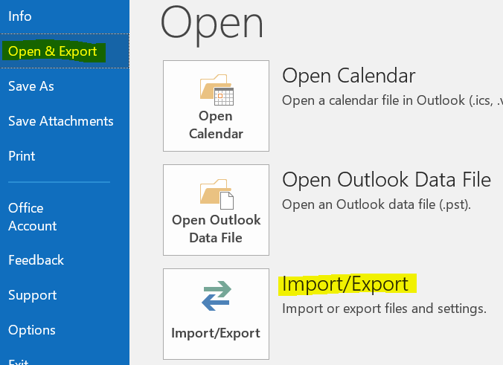

1.c Select Export to a File:

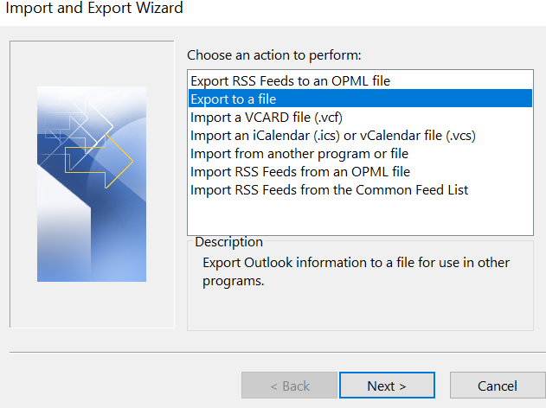

1.d Select PST:

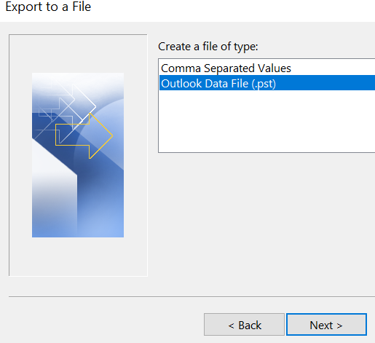

1.e Select the Folders that need to be exported:

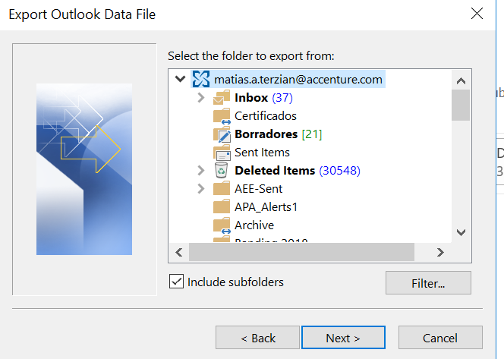

1.f Save the export to the desired location:

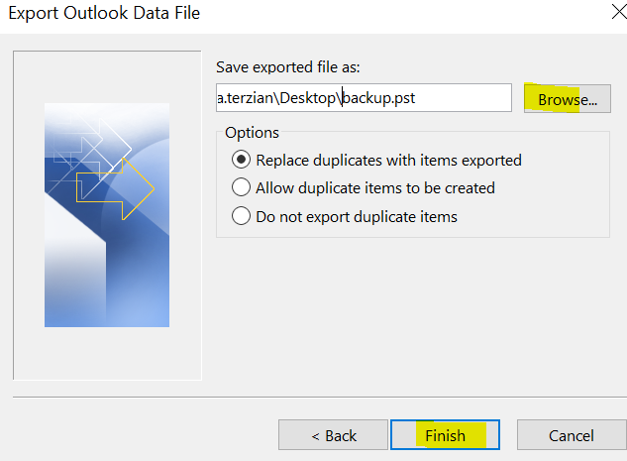

2. If needed, the user can upload the PST file to **OneDrive** and share as needed.

3. **Custom Shared Mailboxes** can be enabled with an **Online Archive**

**4.** Reach out to IAM team to enable the online archive (IAM team SNOW group **INFRADELV-IAM-IGA-OPER**)

4.a Once the archive is enabled please refer the [link](https://in.accenture.com/mycomputer/using-the-auto-archive-feature/) to enable the retention tag

4.b Apply retention polices to the Shared Mailbox’s folders as needed by Right Clicking on the desired folder -> Properties -> Policy:

# Information on shared mailbox owner/AD group associated

**OR**

# Changing Owners/information on the Shared Mailbox Request

Please refer to [link](https://ts.accenture.com/sites/dsext/Active%20Directory/%e2%80%8b%e2%80%8b%e2%80%8b%e2%80%8b%e2%80%8b%e2%80%8b%e2%80%8b%e2%80%8b%e2%80%8bIAM%20ServiceNow%20Queue%20and%20Ticket%20Assignment%20Matrix.aspx) for any queries associated with shared mailbox details. If found any issues assign incident to **INFRADELV-IAM-IGA-OPER**

# User Unable to login to Shared Mailbox

There are several reasons why a user may not be able to login to any given Shared Mailbox. Below steps will cover a potential fix for the “You don’t have permission to access” error message.

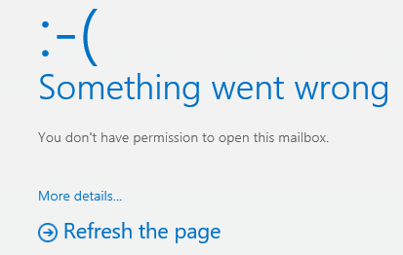

There are a variety of reasons you may be unable to access your Shared Mailbox:

* Only **members** of the Active Directory Group associated with your Shared Mailbox will have access to the mailbox – Owners and Sponsors of the group are NOT, by default, members of the Active Directory Group. Use the Group Management Tool at <https://directory.accenture.com> to manage members in your AD group.
* The WBS element provided on the provisioning form is invalid.
* If you are outside the Accenture network, you may need to connect to VPN.
* Only Shared Mailboxes with Completed status are accessible.

Make sure the user has membership over the AD group.

* 1. Request the user to provide the associated AD group.
  2. Login to the WebAdmin site

<https://directory.accenture.com/WebAdmin/default.aspx>

* 1. Do a search for Groups and search the provided AD group
  2. Make sure the user is added on the Members list.
  3. If the user is showing as a member check the logs on the group:

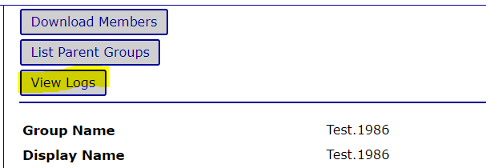

* 1. See on the logs if the user was recently added to the group:

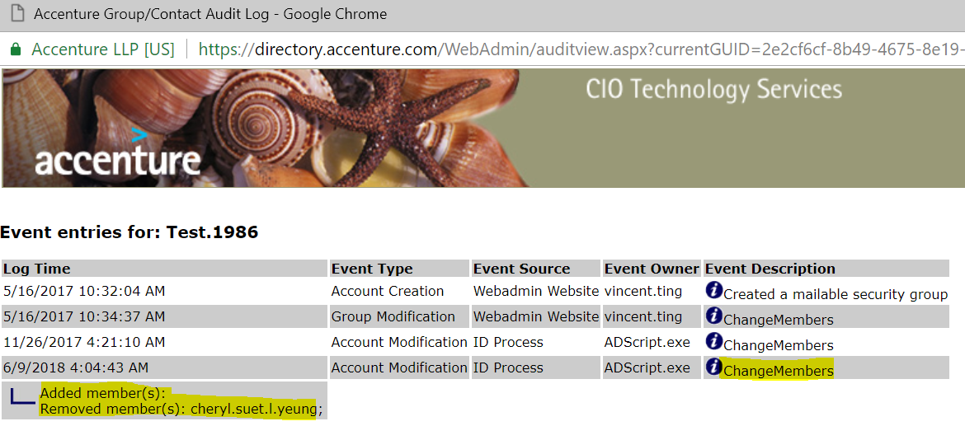

* 1. If the user was indeed recently added, keep in mind that replication can take about 48-72hs

If the user has membership on the Security Group and a reasonable amount of time has passed, raise an incident with M&C team (SNOW queue MSGCOLLAB-O365-OPER) for shared mailbox inaccessibility.

# POP3 Mailbox access issue

Whenever user faces issue in accessing POP3 mailbox from outlook and OWA perform the checks as below:

1. Check if Mailbox is POP3 Protocol enabled or not from **user status** site under **Mail & Collab** Tab: ( <https://directory.accenture.com/UserStatus/> )

  
**Note**- For all POP3 mailboxes POP3 should be enabled, if it’s not enabled please assign incident to IAM team (SNOW group INFRADELV-IAM-IGA-OPER) to get this protocol enabled

1. Check if mentioned POP3 mailbox is **MFA excluded**, all POP3 Mailboxes should be MFA excluded.
2. Search for **CIO.Security.Architecture.SA.Exclusion** group in mentioned POP3 mailbox membership using **User status** site under **Group Membership** Tab

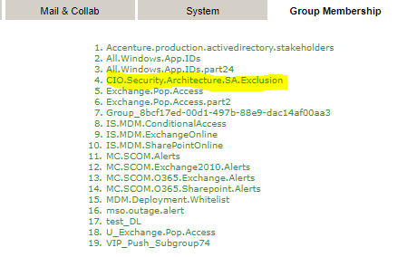

**Note**- All POP3 mailboxes should be MFA excluded, if it’s not please raise an RITM by referring [link](https://ts.accenture.com/sites/dsext/Active%20Directory/IAM%20Services%20supported%20via%20service%20request%20(RITM).aspx) to IAM team (INFRADELV-IAM-IGA-OPER) to get the exclusion done.

1. Check with user which User ID & Password is being used to login mailbox? It should be POP3 mailbox name in user ID and its own password. If user do not have POP3 mailbox password, reach out to IAM Operations team (SNOW group - INFRADELV-IAM-IGA-OPER).
2. Ask user to check in outlook webmail access (OWA) using below URL with POP3 mailbox name and its Password:

<https://myemail.accenture.com/owa/XXX@accenture.com>

**Note** - Amend mailbox name instead of **XXX**

1. If issue is still not fixed assign incident to **INFRADELV-IAM-IGA-OPER** bin to get license status checked.
2. If user is trying to **configure POP3 mailbox outlook in Accenture managed PC/Laptop**, then ask user to do Telnet from his system using command Prompt (CMD):
3. Type windows+R
4. Type telnet, If the below error is obtained

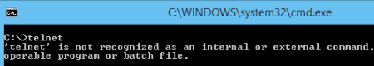

1. Follow the steps below to enable the telnet client through command line
2. Run the below command in command prompt with administrator permissions.

**dism /online /Enable-Feature /FeatureName:TelnetClient**

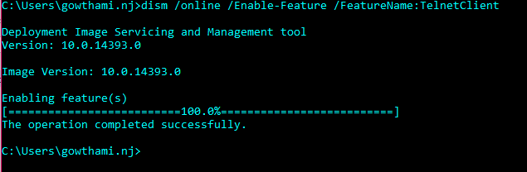

That’s it, after a few seconds telnet should be ready to use.

Type **Telnet myemail.accenture.com 443** and hit enter Key

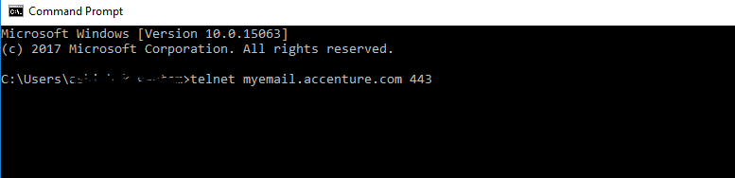

Result should be as below:

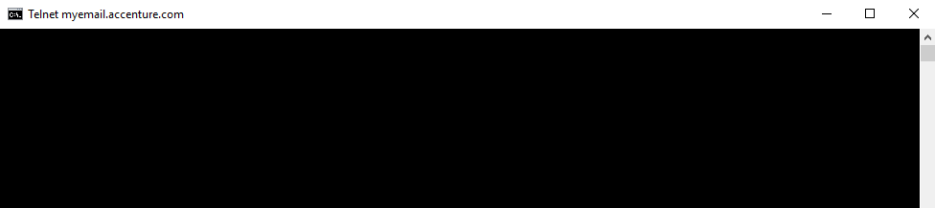

**Note**- If result is blank screen, that means there is no connection issue and all required ports are opened. And if user received an error then there is some port or network issue, so ask user to work with local network Team.

1. If user try to **configure or integrate POP3 mailbox in some application** then connectivity from application to mailbox should be opened on **995 Port** Please ask user to do Telnet from application server using command Prompt (CMD):

Type **Telnet myemail.accenture.com 995** and hit enter Key

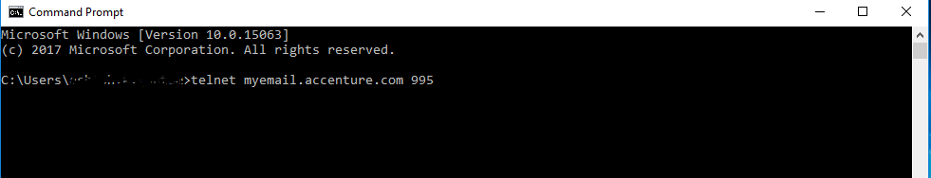

Result should be as below:



**Note**- If result is blank screen, that means there is no connection issue and all required ports are opened. And if user received an error then there is some port or network issue, so ask user to work with local network Team.

1. If user still facing issues please assign incident to **MSGCOLLAB-O365-OPER** bin with below details to get further checking form M&C side

* Full Error screenshot
* Telnet Result from command prompt (CMD) –> **Telnet myemail.accenture.com 995**